Proposal Submission Components
Tender P-55/2026

Technical Proposal
This technical proposal covers the On Premises Oracle Components and solution.

Proposal Scope and Compliance Basis
We propose a customer-managed, entirely on-premises Oracle deployment comprising Oracle AI Database 26ai on Oracle Exadata Database Machine; Oracle Data Integrator (ODI); Oracle GoldenGate, including its documented Iceberg target capability where applicable; Oracle Analytics Server (OAS); Oracle Key Vault; and the Oracle Database options Real Application Clusters (RAC), Partitioning, Advanced Security, and Database Vault.
The database proposal uses Oracle AI Database 26ai's documented lakehouse-related capabilities. All proposed processing and management components will remain inside the designated on-premises network perimeter, as required by tender section 16(1).
This is a technical proposal for the named Oracle components.

Proposed Technical Architecture
The proposed Oracle Data Warehouse solution integrates data ingestion, transformation, storage, analytics, and security. ODI and GoldenGate support data integration and replication, while Oracle AI Database 26ai on Exadata provides a high-performance platform for silver and gold data layers and analytical workloads. OAS enables reporting and dashboards, complemented by Oracle security solutions for data protection, access control, and encryption. The solution is designed to meet data warehousing and analytical requirements, subject to interoperability and performance validation.

Ingestion and transformation: ODI performs scheduled batch integration, mappings, ELT, and load-plan orchestration. GoldenGate captures supported database changes and replicates them to Oracle Database or, subject to interoperability testing, to Iceberg tables on an on-premises S3-compatible object store. ODI can invoke REST and SOAP services but is not the complete tender API Framework. Evidence: ODI web services; GoldenGate Iceberg

Silver and Gold serving: Oracle AI Database 26ai on Exadata holds governed relational Silver and Gold data, including dimensional models, partitioned fact tables, aggregates, and mixed transactional and analytical workloads. RAC provides database-instance availability and cross-instance parallel execution; Partitioning supports pruning and partition-wise processing. Exadata should be benchmarked against PRAL's workload rather than described as architecturally identical to another MPP engine. Evidence: Exadata architecture; parallel execution
Lakehouse access: The on-premises database can use DBMS_CLOUD and ORACLE_BIGDATA to access supported object-store data and Iceberg external tables. Oracle also documents on-premises Iceberg table creation through a mounted catalogue, with stated prerequisites and restrictions. Evidence: customer-managed DBMS_CLOUD; Iceberg access; Iceberg table restrictions

Analytics and security: OAS connects to Oracle AI Database 26ai for datasets and semantic models, dashboards, self-service analysis, and operational reporting. Advanced Security provides database encryption and query-result redaction; Database Vault restricts privileged access; Key Vault centrally manages Oracle encryption keys. Evidence: OAS sources; TDE; Key Vault

Technical Compliance Matrix
The Technical Compliance Matrix below provides a detailed assessment of the proposed Oracle solution against PRAL’s technical requirements specified in the RFP. Each requirement is mapped to the proposed solution’s compliance status, relevant Oracle product capabilities, and supporting references from official Oracle documentation to substantiate the technical compliance and proposed architecture.
Tender technical requirement | Reference | Proposed Oracle product | Status | Compliance comment and Oracle evidence
Entire CDH remains on premises without cloud or external-network dependency | 16(1); 5.7 | Customer-managed Oracle stack on Exadata | FULLY | The Oracle components can be deployed on premises,  Oracle evidence Exadata overview | OAS installation
OEM-engineered, scale-out warehouse with parallel analytical processing | 16(4); 5.7 | Exadata; Oracle AI Database 26ai; RAC | FULLY | Oracle documents scale-out database and storage servers and parallel execution across RAC. Tender-specific benchmark, sizing, and concurrency evidence remains necessary; RAC is shared-storage, not shared-nothing.  Oracle evidence Exadata configurations | parallel execution
Multi-level parallelism, partition pruning, and warehouse optimization | 5.7 | Oracle AI Database 26ai; Partitioning; RAC | FULLY | Oracle documents parallel query and DML, cross-instance parallelism, pruning, and partition-wise operations. PRAL response-time targets still require a workload benchmark.  Oracle evidence parallel execution | Partitioning
Relational Silver and Gold layers, ACID transactions, dimensional models, and aggregates | 5.4 | Oracle AI Database 26ai; Partitioning | FULLY | The database can implement transactional relational tables, partitioned fact structures, and materialized aggregates. This does not cover the entire four-layer architecture.  Oracle evidence Partitioning | materialized views
Native OLTP and OLAP in one engine, HTAP, and published global reference evidence | 5.4; 16(11) | Oracle AI Database 26ai on Exadata | FULLY | The database supports transactional and analytical workloads in one engine.  Oracle evidence Exadata architecture | parallel processing
Scheduled batch ingestion, ELT mappings, dependencies, and orchestration | 5.3 | ODI | FULLY | ODI documents mappings and load plans. Source breadth, 3,000-plus jobs, availability, recovery, and operating SLAs require design and workload proof.  Oracle evidence ODI overview
Inbound REST and SOAP API data ingestion | 5.2; 5.3 | ODI | FULLY | ODI invokes REST and SOAP services and processes responses. Its documentation does not establish the full GraphQL, webhook, credential rotation, schema inference, dead-letter, and centralized-policy requirements.  Oracle evidence ODI web services
Log-based Oracle and SQL Server CDC with tender latency and source-impact limits | 5.3 | GoldenGate | FULLY | GoldenGate provides log-based replication. SQL Server capture needs source-side preparation and Oracle supplemental logging can increase redo; zero impact and sub-second performance require validation.  Oracle evidence GG architecture | SQL Server | Oracle redo
CDC delivery to Iceberg on on-premises S3-compatible object storage | 5.3; 5.4 | GoldenGate for Distributed Applications and Analytics | FULLY | Oracle documents Iceberg Replicat and third-party S3-compatible endpoints. Updates and deletes use merge-on-read equality deletes, so reader, catalogue, store, and latency must be tested together.  Oracle evidence GG Iceberg target
CDC, real-time streaming, and API ingestion as first-class ingestion-stack capabilities | 16(3) | ODI; GoldenGate | PARTIALLY | The products cover documented portions of CDC and API invocation, but not the entire native streaming and API framework..  Oracle evidence ODI web services | GG components
Direct on-premises S3-compatible data access and federated lake and warehouse queries | 5.4; 5.7 | Oracle AI Database 26ai lakehouse-related packages | FULLY | Customer-managed DBMS_CLOUD and ORACLE_BIGDATA support documented object-store access..  Oracle evidence DBMS_CLOUD | object-store setup
Governed semantic models, self-service analysis, and Gold dashboards | 5.11 | OAS | FULLY | OAS supports Oracle AI Database 26ai for datasets and semantic models. Model design, permissions, and performance are implementation tasks.  Oracle evidence OAS certification | Semantic Modeler
Pixel-perfect operational reports, scheduling, and distribution | 5.11 | OAS Publisher | FULLY | Oracle documents pixel-perfect reports and publishing capabilities; tender-specific templates, schedules, volume, and channels still need testing.  Oracle evidence OAS reports
BI connectivity to both MPP database and proposed on-premises object store | 16(6) | OAS | FULLY | Oracle certifies OAS connectivity to Oracle AI Database 26ai, Oracle Analytics Server (OAS) to connect to a non-Oracle Object Storage  OAS doesn’t have native connectors for all object storage providers, but you can still integrate them using REST API, Web Data Connector, or JDBC/ETL staging  Oracle evidence OAS supported sources
Database-at-rest encryption and independent Oracle database key management | 5.7; 10 | Advanced Security; Key Vault | FULLY | TDE protects its documented Oracle Database scope, and Key Vault centrally manages its keys. This does not extend automatically to every object-store, middleware, log, and backup component.  Oracle evidence TDE | Key Vault
Dynamic masking and static format-preserving masking for non-production data | 5.7; 9 | Advanced Security Data Redaction | PARTIALLY | Data Redaction masks query results but does not provide the tender's static, referentially consistent non-production masking and tokenization in the requested Oracle options.  Oracle evidence Data Redaction | redaction vs masking
Restrict privileged administrators and separate database security duties | 5.7; 5.10 | Database Vault | FULLY | Database Vault documents realms, command rules, and separation-of-duties controls for Oracle Database. It does not provide CDH-wide access governance.  Oracle evidence Database Vault guide
Database row and column access, | 5.7; 5.10 | Oracle AI Database 26ai; Database Vault | FULLY | Oracle VPD - Oracle evidence Virtual Private Database | auditing

ELT / Data Integration Architecture
- Network & connectivity architecture
- Infrastructure design document
- Source-system connectivity matrix
- Source-to-target mapping approach
- Data ingestion methodology
- CDC methodology
- Schema enforcement approach
- Data-quality controls
- API ingestion approach
- Real-time streaming approach
- Log-based CDC evidence
The tender requires native support for CDC, real-time streaming and API-based ingestion.

MPP Enterprise Data Warehouse
- MPP architecture/design
- Compute and storage infrastructure design
- Node sizing
- Cluster architecture
- Storage-performance characteristics
- Query-processing architecture
- Workload-management approach
- Query-optimization approach
- Published performance benchmarks/reference evidence
- OEM/product documentation
- MPP architecture/design

MPP (Massively Parallel Processing) is an architecture in which processing is distributed across multiple compute resources to execute workloads in parallel.

Oracle Exadata is an engineered platform for Oracle Database that supports parallel SQL execution, RAC, and intelligent storage processing through features such as Smart Scan and SQL offloading.

Important distinction: Oracle RAC and parallel query capabilities do not, by themselves, establish that Exadata meets every definition of a shared-nothing MPP architecture. Exadata uses a shared-database architecture with shared storage access across database nodes.

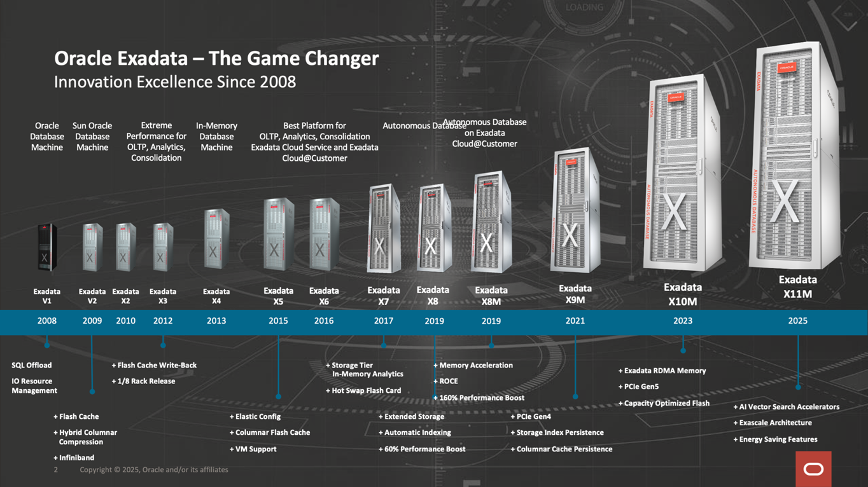

Oracle Exadata Unique Features for Data Warehouse Processing

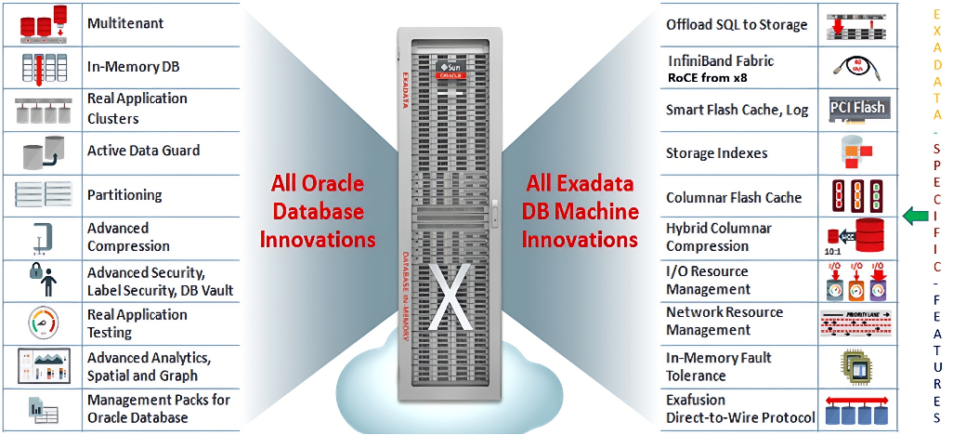

Oracle Exadata and Database 26ai list of some features for Data Warehouse Processing

Feature | Advantages
Exadata Smart Scan | Offloads eligible SQL operations to storage servers, reducing data transfer.
Storage Indexes | Reduce unnecessary storage I/O by skipping irrelevant data regions.
Hybrid Columnar Compression (HCC) | Reduces storage requirements and improves scan efficiency for eligible data.
Oracle Database In-Memory | Accelerates analytical queries using in-memory columnar processing.
Partitioning | Improves query efficiency and management of large tables.
Parallel SQL Execution | Accelerates large-scale analytical queries through parallel processing.
Smart Flash Cache | Accelerates access to frequently accessed or suitable data.
Oracle RAC Scale-Out | Supports database availability and workload distribution across nodes.
Resource Manager | Prioritizes and balances ETL, reporting, and analytical workloads.
Direct-Path Loading | Enables efficient bulk data loading for warehouse operations.
In-Memory Parallel Execution | Combines parallel query processing with in-memory data access where applicable.
Advanced SQL Analytics | Supports complex joins, aggregations, and analytical functions for business intelligence.
AI Vector Search | Finds semantically similar records, documents, and content using vector embeddings.
Hybrid Search | Combines keyword search with semantic vector search to improve retrieval relevance.
Vector Indexes | Accelerate approximate similarity searches across large vector datasets.
AI-Powered Text Summarization | Summarizes documents and retrieved information using supported AI models and services.
Unified Data Access | Allows AI queries to combine vector retrieval with relational data and SQL-based filtering.
AI Vector Search | Finds semantically similar records, documents, and content using vector embeddings.
Hybrid Search | Combines keyword search with semantic vector search to improve retrieval relevance.
Natural Language to SQL (Select AI) | Enables users to ask questions in natural language and generate SQL queries

The combination of Oracle Exadata X11M and Oracle AI Database 26ai provides an integrated, high-performance platform for enterprise data warehousing. It combines Exadata's scale-out architecture, intelligent storage processing, and parallel analytics with Oracle Database's advanced query optimization and data warehousing capabilities to support large-scale data processing, complex analytical queries, and growing enterprise data volumes.

Fore detailed documentation please refer to below link

https://docs.oracle.com/en/database/oracle/oracle-database/26/dwhsg/database-data-warehousing-guide.pdf

https://www.oracle.com/a/ocom/docs/engineered-systems/exadata/exadata-x11m-ds.pdf

- Compute and storage infrastructure design

Oracle Exadata Database Machine employs a modern scale-out architecture encompassing database compute, storage, network, and software. Uniquely designed to be the ideal platform to run Oracle Database, Oracle Exadata enables enterprises to add capacity and increase performance as workloads scale. Oracle Exadata utilizes state-of-the-art hardware and purpose-built software to drive the highest database performance. All database and storage servers are interconnected with each other, communicating over an intelligent, high-speed, low-latency network fabric.

Fundamental to the architecture of Exadata is modular, shared, smart storage. Each Storage Server is capable of interpreting and processing data independently.
The CPUs in the storage servers do not replace database CPUs. Instead, they accelerate database-intensive workloads similar to how graphics cards accelerate image-intensive workloads.

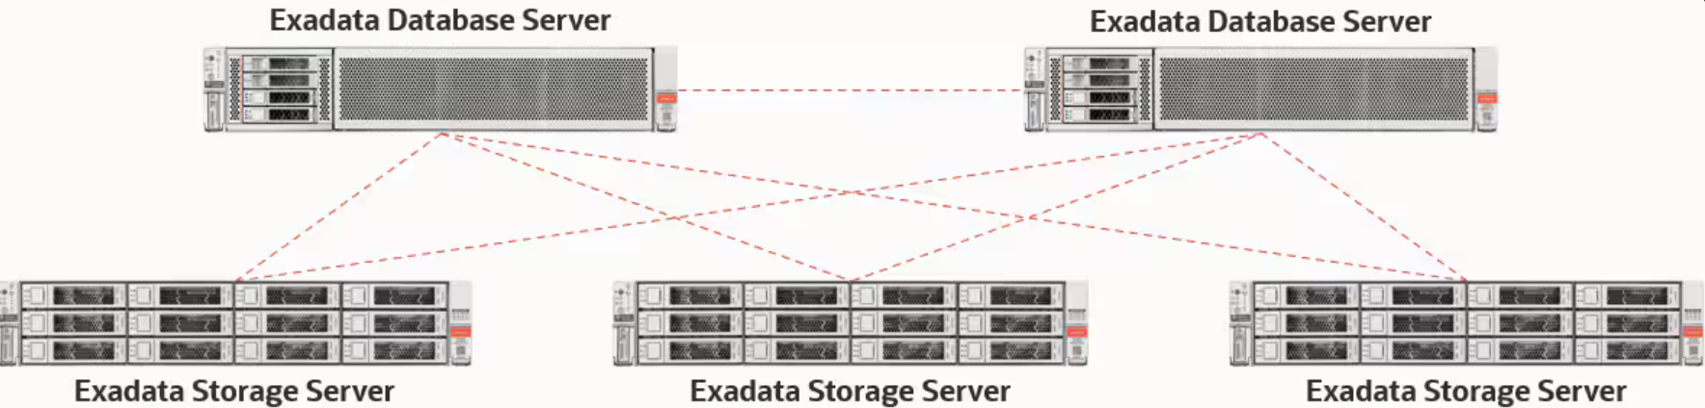

- Node sizing

Following is Exadata X11M Database Server Physical Node Sizing.

Component Name | Description
CPU | 2 x 96-core AMD EPYC 9J25 processors, 2.6 GHz (up to 4.5 GHz)
Memory | 3 TB memory
Flash | 2 x 3.84 TB NVMe Flash SSD
Network | Client/backup adapter 1: 2 x 10/25 Gb Ethernet ports (SFP28) Client/backup adapter 2: 2 x 10/25 Gb Ethernet ports (SFP28) 1 x 1 Gb Ethernet port (RJ45, management) 1 x 1 Gb Ethernet port (RJ45, ILOM) 2 x 100 Gb QSFP28 RoCE Fabric ports
X11M Storage Server
CPU | 2 x 32-core AMD EPYC 9J15 processors  2.95 GHz (up to 4.4 GHz)
Memory | 256 GB
Flash | 4 x 6.8 TB NVMe PCIe 5.0 performance-optimized Flash cards
Network | 2 x 100 Gb QSFP28 RoCE Fabric ports  1 x 1 Gb Ethernet port (RJ45, management)  1 x 1 Gb Ethernet port (RJ45, ILOM)

- Cluster architecture

Oracle Database can be configured in two basic ways: as a single instance (SI) database (non-cluster) or a Real Application Clusters (RAC) database. A single instance database has the Oracle software, database files, memory and processes all on one server.

A Real Application Clusters (RAC) Database has multiple database Instances hosted on a RAC Cluster. These instances access a single set of Database files on Shared Storage. Frequently the Shared storage is provided by an ASM instance local to the node hosting the RAC database instance.

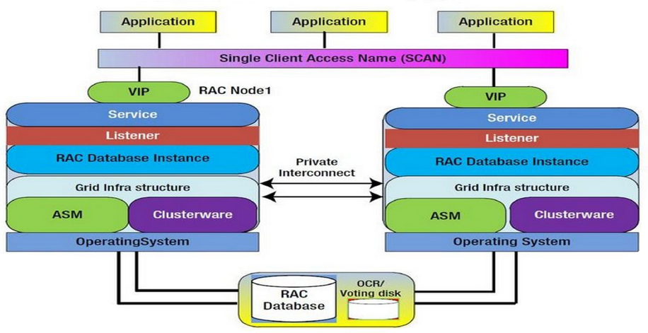

- Storage-performance characteristics

Configuration Name | Performance characteristics stats
Maximum SQL Flash Bandwidth2 | 100 GB/s
Maximum SQL Read IOPS1,3 | 1,200,000
Maximum SQL Write IOPS4 | 1,000,000
Read Latency (lowest measured)6 | ~150 microseconds
Performance Optimized PCI Flash  Capacity (Raw) 5 | 27.2 TB
Disk Data Capacity (Raw) 5 | 264 TB

- Query-processing architecture

Oracle Exadata System Software includes Smart Scan technology (also known as SQL Offload), which offloads data-intensive SQL operations from the database servers directly into the storage servers. By pushing SQL processing to the storage servers, data filtering and processing occur immediately and in parallel across all storage servers, as data is read from disk and flash. Only the rows and columns directly relevant to a query are sent to the database servers. By filtering rows and columns at the storage server, not only does less data get sent to the database servers, but the scan typically runs faster by virtue of the increased aggregate number of CPUs available within the storage servers, which results in greater parallelism.

Smart Scan greatly accelerates query execution, eliminates bottlenecks, and significantly reduces the CPU usage of the database servers. Exadata Smart Scan works in collaboration with Exadata Storage Indexes, which reduces the amount of IO required to satisfy the smart scan process.

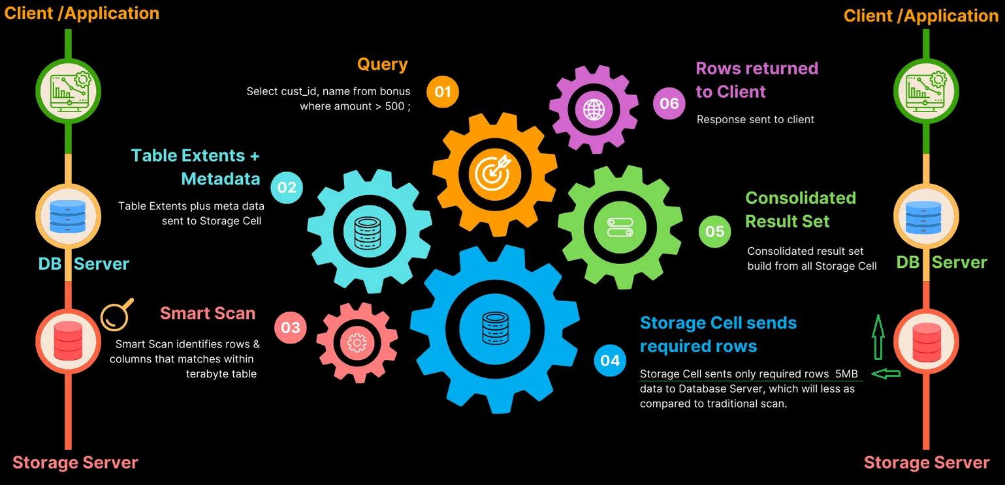
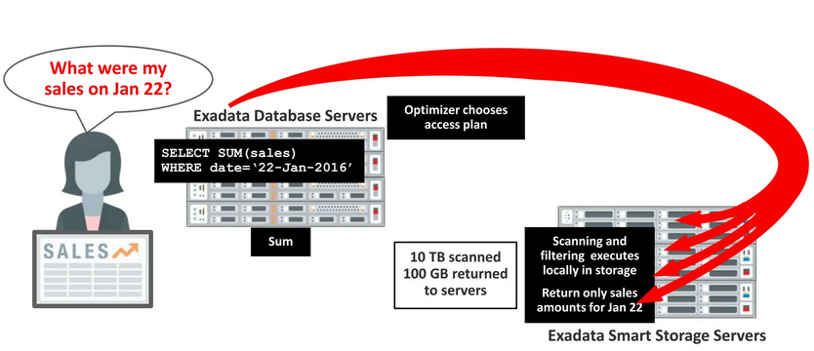

- Workload-management approach

Oracle Exadata provides integrated workload management through Oracle Database Resource Manager and Exadata I/O Resource Management (IORM). These capabilities enable administrators to prioritize critical workloads, allocate CPU and storage I/O resources, and manage resource contention across concurrent ETL, reporting, and analytical workloads.

- Query-optimization approach

Oracle Exadata X11M combined with Oracle AI Database 26ai optimizes data warehouse query execution through cost-based optimization, parallel SQL execution, star-schema query transformations, partition pruning, and Exadata Smart Scan. These capabilities help reduce unnecessary storage I/O and data movement while accelerating eligible analytical queries.

- Published performance benchmarks/reference evidence

Please refer “Record-breaking Analytics I/O Performance” section in below mentioned Exadata datasheet link

https://www.oracle.com/a/ocom/docs/engineered-systems/exadata/exadata-x11m-ds.pdf
https://blogs.oracle.com/database/oracle-announces-oracle-ai-database-26ai

- OEM/product documentation

For Oracle Exadata machine detailed documentation please refer to below links

https://www.oracle.com/a/ocom/docs/engineered-systems/exadata/exadata-x11m-ds.pdf
https://docs.oracle.com/en/engineered-systems/exadata-database-machine/books.html

Object Storage / Lakehouse
- Object-storage architecture
- Capacity plan
- Redundancy design
- Performance characteristics
- Connectivity architecture
- Bronze/Silver/Gold architecture
- Open-table-format support
- Native MPP-to-object-storage integration
- Product/OEM documentation
The object-storage solution must be purpose-built and natively compatible with the proposed MPP platform.

AI/ML & Compute Cluster
- Compute cluster architecture diagram
- AI/ML platform design
- Node sizing
- Compute/storage separation
- Workload-isolation approach
- Micro-batch processing architecture
- Streaming processing architecture
- Scalability approach
The evaluation specifically requires the compute-cluster architecture diagram and AI/ML platform design.

BI / Analytics
- BI/semantic-layer architecture
- Proposed BI tool
- Tool-selection justification
- Integration with MPP
- Integration with Lakehouse
- Integration with Data Governance/Catalog
- Self-service analytics architecture
- Reporting/dashboard architecture
The proposed BI tool must have native connectivity to the Object Store and MPP platform and support self-service reporting/dashboarding.
- BI/semantic-layer architecture

Oracle Analytics Server includes a semantic layer, A semantic model is a metadata model that contains physical database objects that are abstracted and modified into logical dimensions. A semantic model is designed to present data for analysis according to the structure of the business.
The semantic model contains three layers of metadata that build on each other and prepare the data source's data for users to query and analyze.
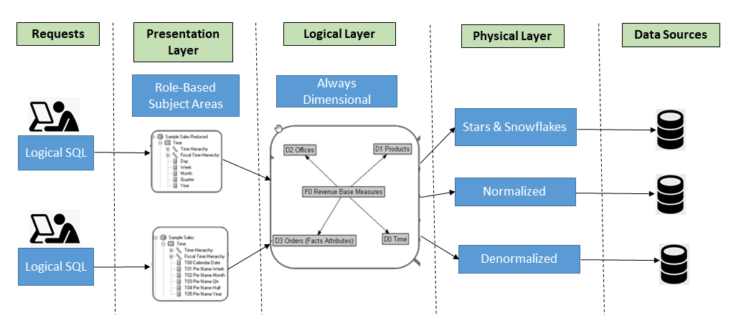
Physical Layer: Defines the physical data sources, tables, columns, joins, and connections required by Oracle Analytics to access data and execute queries against underlying databases.
Logical Layer: Defines the business model by mapping physical data into logical entities, measures, dimensions, hierarchies, and calculations while hiding the complexity of underlying data sources.
Presentation Layer: Provides simplified, secure, role-based views of the logical model through business-friendly subject areas and folders, enabling users to create reports and dashboards without understanding the underlying data structures.

- Proposed BI tool

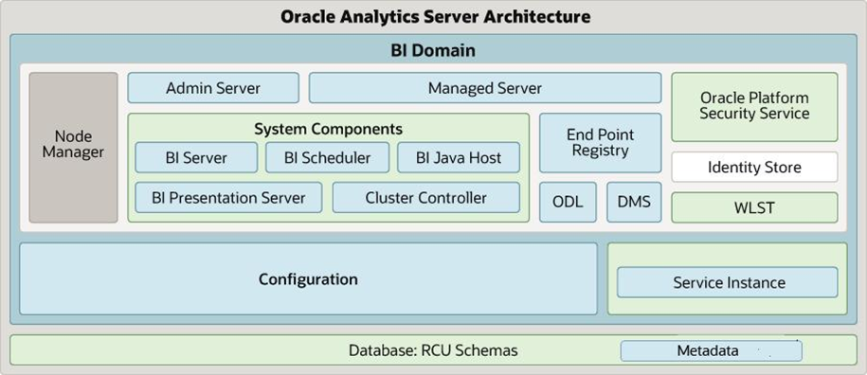

- BI Domain: A centralized environment containing all OAS components, services, and configurations. It can run on a single server or across multiple servers for scalability and high availability.
- Administration Server: Manages OAS configuration, security, and administrative operations through WebLogic Console and Fusion Middleware Control.
- Managed Server: Hosts and runs Java-based OAS applications, including Publisher, security services, and web applications.
- Node Manager: Controls the starting, stopping, restarting, and monitoring of WebLogic servers and OAS system components.
- BI Server (OBIS): Processes analytical queries, manages the semantic model, and retrieves data from connected data sources.
- BI Scheduler (OBISCH): Schedules and delivers analyses and automated reporting tasks at specified times.
- BI Presentation Server (OBIPS): Manages the presentation of analytics and reports to users and maintains the Presentation Catalog.
- Cluster Controller (OBICCS): Distributes analytical requests across multiple BI Servers for load balancing and availability.
- Oracle Analytics Publisher: Generates, manages, schedules, and distributes formatted enterprise reports.
- Oracle Platform Security Services (OPSS): Provides authentication, authorization, and security integration for OAS.
- Identity Store: Maintains or connects to user identities and groups used for authentication and access management.
- Configuration: Stores OAS system settings, service configurations, and environment-specific parameters.
- Service Instance: Represents the configured OAS services, metadata, and related runtime resources.
- Repository Creation Utility (RCU) Schemas: Database schemas that store metadata and infrastructure information required by OAS.
- Metadata: Contains information about semantic models, data-source mappings, system settings, and analytical configuration.
- WebLogic Scripting Tool (WLST): Provides command-line scripting for configuration, administration, and automation of WebLogic and OAS.
- Oracle Diagnostic Logging (ODL): Provides diagnostic logs for monitoring, troubleshooting, and identifying system errors.
- Diagnostic Monitoring Service (DMS): Collects runtime performance metrics and diagnostic information for monitoring OAS components.

- Tool-selection justification

Oracle Analytics Server (OAS) – Feature Availability
According to Oracle's official documentation, Oracle Analytics Server includes most of the features available in Oracle Analytics Cloud.
The information is organized into four main categories.

- Governed Analytics

Feature | OAS Support
Corporate Analytics Dashboards | Yes
Pixel-Perfect Reports | Yes
Enterprise Semantic Models | Yes
Role-Based Access Control (RBAC) | Yes
Data Replication | No

- Self-Service Analytics

Feature | OAS Support
Data Preparation | Yes
Data Visualization | Yes
Storytelling | Yes
Sharing and Collaboration | Yes
Workbook Email Scheduling | No
Incremental Loading for Datasets | No

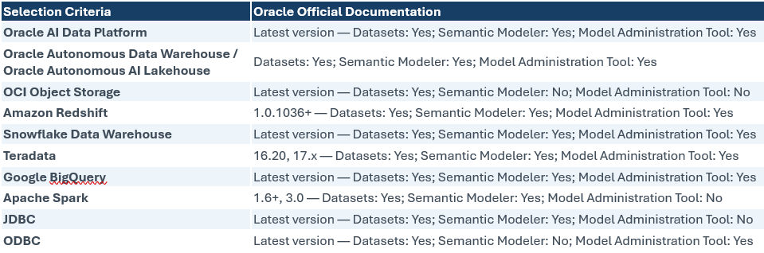

Fore detailed documentation please refer to below links

https://docs.oracle.com/en/middleware/bi/analytics-server/whats-different-oas/index.html

https://docs.oracle.com/en/middleware/bi/analytics-server/administer-oas/certification-supported-data-sources.html

- Integration with MPP

Based on Oracle's official Manage Connections to Data Sources documentation.

- Create Data Source Connections: Configure OAS connections to the supported MPP platform using the required host, port, username, password, and service name.
- Configure Authentication: Set up supported database authentication options and credentials.
- Configure System Connections: Enable System connection for Semantic Modeler or Model Administration Tool, where supported.
- Manage Connections: Create, update, and maintain MPP data-source connections.
- Configure Connection Permissions: Assign Read-Only, Read-Write, or Full Control access to authorized users and application roles.
- Configure Connection Sharing: Make approved MPP connections available through shared folders.
- Validate Connectivity: Verify that OAS connections can access the MPP data source for datasets or semantic modeling.

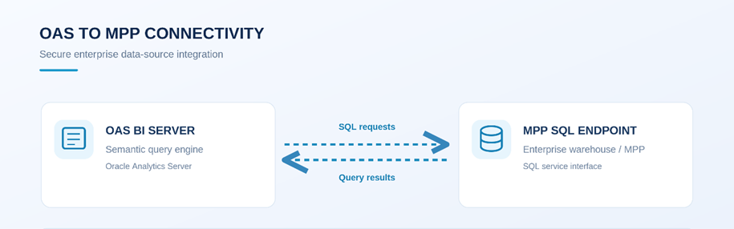

For Manage Connections to Data Sources in OAS, please refer below link for detail

https://docs.oracle.com/en/middleware/bi/analytics-server/user-oas/manage-connections-data-sources.html

- Integration with Data Governance/Catalog

- Configure OAS integration with enterprise authentication (LDAP/SSO).
- Based on Oracle's official security documentation, you can include these important points:
- Authentication Provider: Configure integration with LDAP, Microsoft Active Directory, or Oracle Internet Directory for user authentication.
- Application Roles: Configure and manage OAS application roles for authorized users and groups.
- Access Permissions: Grant or revoke application-role permissions based on the approved access requirements.
- Role Assignment: Assign application roles to users and groups through the OAS Console.
- Semantic Model Security: Configure approved access privileges within the semantic model and Presentation Services.
- Single Sign-On (SSO): Configure SSO authentication where required.
- SSL Security: Configure SSL for secure communication between OAS components.
- Credential Store: Administer supported credential-store configurations for secure credential management.
These capabilities are documented in Oracle's security setup workflow and security architecture. For detail please refer below links
https://docs.oracle.com/en/middleware/bi/analytics-server/security-oas/typical-workflow-security.html

https://docs.oracle.com/en/middleware/bi/analytics-server/security-oas/overview-security-oracle-analytics-server.html

- Self-service analytics architecture

OAS includes predefined roles such as DV Content Author, BI Content Author, BI Consumer and BI Data Model Author.

- BI Service Administrator: Configure and manage administrative access to OAS and delegate privileges through the Console.
- DV Content Author: Assign permissions to create workbooks, load data, and explore data visualizations.
- BI Content Author: Configure access for creating analyses, dashboards, and pixel-perfect reports.
- DV Consumer: Assign permissions for users to explore data visualizations.
- BI Consumer: Configure permissions to view and run workbooks, analyses, dashboards, and pixel-perfect reports.
- BI Data Model Author: Assign permissions to authorized developers for creating and managing semantic models.
- Role Membership Management: Manage user and group membership in application roles, including inherited permissions.

For Managing Security in Oracle Analytics Server, please refer below link for detail review

https://docs.oracle.com/en/middleware/bi/analytics-server/security-oas/predefined-application-roles.html

Real-Time / Streaming Architecture
- Streaming architecture diagram
- Streaming compute cluster design
- Node/cluster sizing
- Workload-isolation approach
- Throughput benchmarks
- Latency benchmarks
- Comparable deployment evidence
This is explicitly listed as a technical-evaluation document requirement.

Native HTAP / Multi-Model Capability
- HTAP architecture diagram
- Multi-model architecture
- OLTP/OLAP architecture
- Vendor-published benchmark/reference evidence
- Evidence of concurrent OLTP/OLAP processing
- Evidence that HTAP is native/non-federated
This is particularly important because failure to demonstrate native Multi-Model/HTAP capability is stated as a disqualification condition.
- HTAP architecture diagram

Exadata is the ideal platform for a broad range of modern database workloads, including Artificial Intelligence (AI), Analytics, Data Warehousing (DW), In-Memory Analytics, Online Transaction Processing (OLTP), and Internet of Things (IoT).

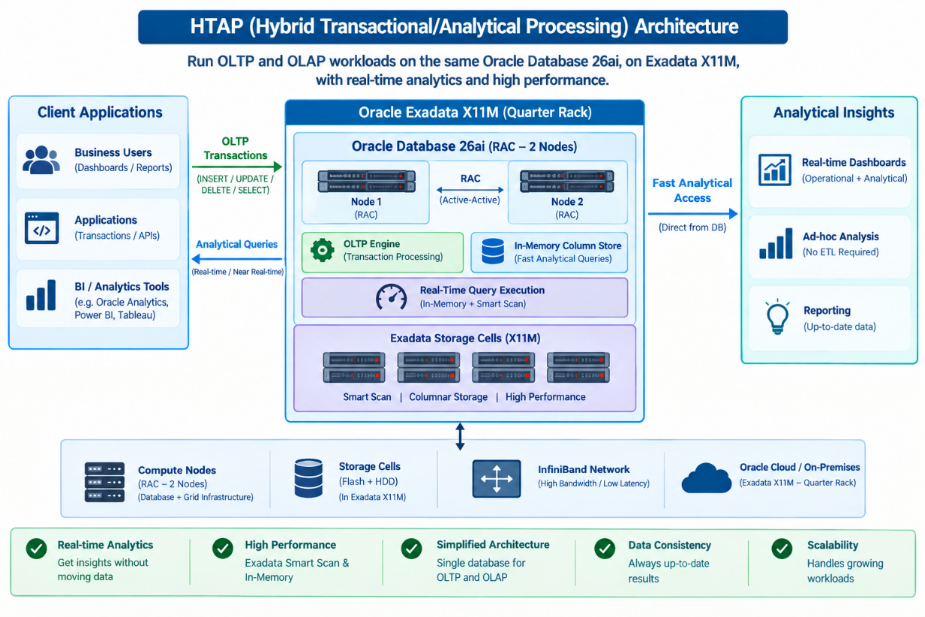

- Multi-model architecture

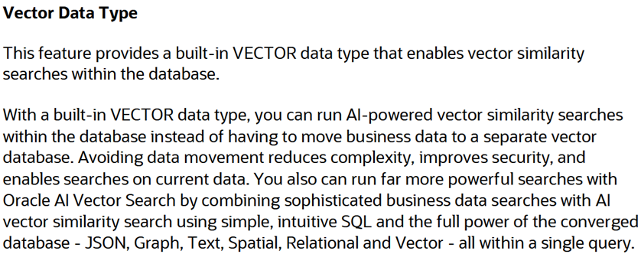

SQL> CREATE TABLE my_vectors (id NUMBER, embedding VECTOR(768, INT8));

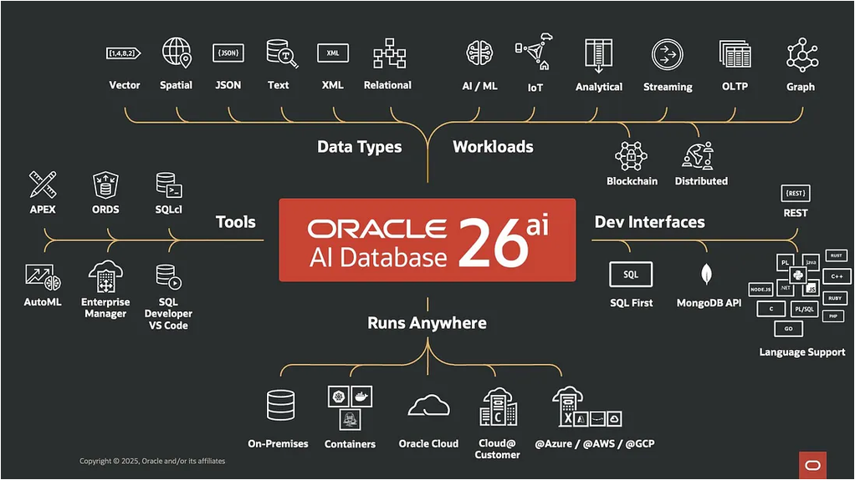

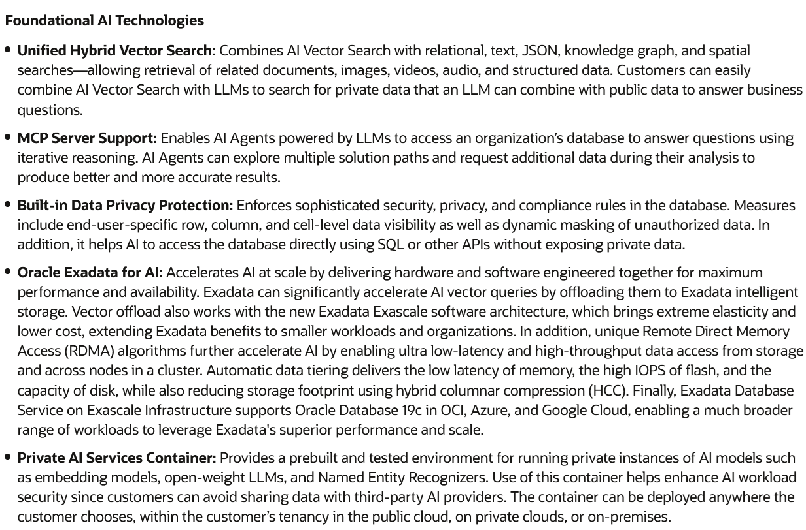
- OLTP/OLAP architecture
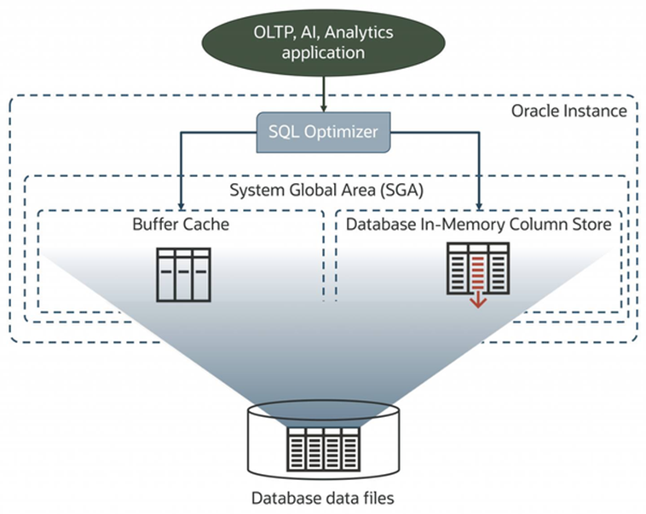
Use Database In-Memory to eliminate ETL/ELT pipelines

Oracle AI Database In-Memory (Database In-Memory) is a suite of features that greatly improves performance for real-time analytics and mixed workloads. The In-Memory Column Store (IM column store) is the key feature of Database In-Memory.

For on-premises Exadata deployments, enabling in-memory processing with flash and XRMEM storage is straightforward. You can allocate memory on Exadata database servers and specify tables or partitions to be replicated in the DBIM format or let Automatic In-Memory make these decisions for you. The data-intelligent Exadata software will automatically cache columnar data in flash and XRMEM on the storage servers.

- Vendor-published benchmark/reference evidence

Oracle's official technical publication highlights the capabilities of Oracle AI Database In-Memory and Oracle Exadata for concurrent Online Transaction Processing (OLTP), Online Analytical Processing (OLAP), and AI workloads within a unified database architecture.
Oracle Database In-Memory utilizes a native dual-format architecture, supporting row-based transactional processing and columnar analytical processing without requiring separate databases or external data synchronization.

Oracle Exadata supports both Extreme Flash (EF) and High Capacity (HC) storage architectures, providing intelligent storage processing, Exadata Smart Scan, flash caching, and Exadata RDMA Memory (XRMEM) to accelerate mixed transactional and analytical workloads.

Oracle's published Exadata X11M performance specifications highlight:
- Up to 100 GB/s flash-based scan throughput per storage server.
- Up to 500 GB/s Exadata Smart Scan throughput per storage server using XRMEM.
- Up to 10x compression, potentially higher depending on the data, through Hybrid Columnar Compression (HCC).
- Extreme Flash (EF) Storage: All-flash architecture optimized for high-performance, low-latency database operations.
- High Capacity (HC) Storage: Disk-based capacity storage accelerated by intelligent flash caching and XRMEM.

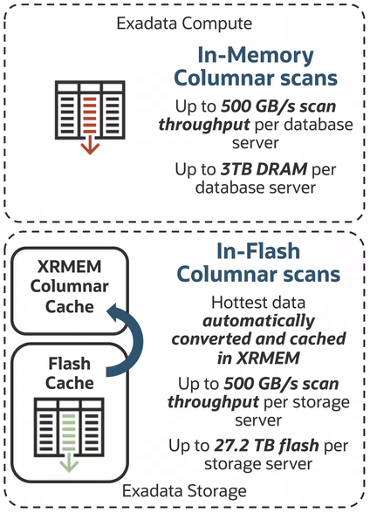

These Oracle-published architectural and performance references demonstrate how Exadata supports high-throughput analytics alongside transactional workloads using an integrated database and storage architecture. The cited throughput figures represent published platform capabilities rather than a dedicated simultaneous OLTP/OLAP benchmark.

For detailed documentation, please refer to the link below:

https://blogs.oracle.com/exadata/oracle-database-inmemory-and-exadata-are-meant-for-agentic-ai-workloads

- Evidence of concurrent OLTP/OLAP processing
For OLTP workload, Exadata X11M uses the latest AMD EPYC processor cores, which enable up to 1.25X more concurrent transactions and up to 1.25X faster serial transactions. Write IOPS increases up to 9% on the storage servers to 1,000,000. Read latency from Exadata RDMA Memory (XRMEM) gets even faster, dropping from 17 microseconds to as low as 14 microseconds – an incredible 21% faster than the previous generation. Finally, single block reads from flash get up to 43% faster.

For Analytics workload, also benefit from faster processors in the database and storage servers, with up to 25% faster analytic query processing on the database servers after Smart Scan and other storage server optimizations have returned results for further/final processing.

For AI Vector Search on Exadata X11M with the latest Exadata System Software accelerates AI workloads by up to 30X by offloading processing to the storage servers.
For detailed documentation, please refer to the link below:

https://blogs.oracle.com/exadata/exadata-x11m
- Evidence that HTAP is native/non-federated

Oracle Exadata X11M supports integrated transactional (OLTP) and analytical (OLAP) processing through Oracle Database and Exadata's intelligent storage architecture. The platform combines database processing, Exadata Smart Scan, Columnar Flash Cache, and Database In-Memory technologies to accelerate mixed workloads within a unified database environment. As documented in the official Oracle Exadata X11M datasheet, key architectural capabilities include:

- Integrated OLTP/OLAP Processing: Oracle Exadata supports transactional and analytical workloads through its integrated database and storage architecture.
- High Capacity (HC) and Extreme Flash (EF) Storage: Both storage configurations support Exadata Smart Scan, intelligent flash caching, and Exadata RDMA Memory (XRMEM).
- Native Columnar Processing: Exadata Columnar Flash Cache automatically transforms frequently scanned data into columnar formats, accelerating analytical queries while maintaining efficient OLTP-style single-row access.
- Unified Data Access: Oracle Database In-Memory on Exadata enables a single query to transparently access data across memory, flash, and disk storage tiers.
- Integrated, Non-Federated Processing: The documented architecture supports OLTP and OLAP execution directly through Oracle Database and its integrated Exadata storage capabilities, without requiring a separate federated analytical query engine for these native operations.

These capabilities provide vendor-published architectural evidence supporting native HTAP processing within Oracle Exadata. The non-federated conclusion is based on the documented integration of Oracle Database and Exadata processing technologies.

For detailed documentation, please refer to the link below:

https://www.oracle.com/a/ocom/docs/engineered-systems/exadata/exadata-x11m-ds.pdf

- Exadata and Database Software Features – Analytics / OLAP

  - Unique Automatic Parallelization and Offload of Data Scans to storage
  - Unique Filtering of Rows in Storage based on 'where' clause
  - Unique Filtering of Rows in Storage based on columns selected
  - Unique Storage Offload of JSON and XML Analytic Queries
  - Unique Filtering of rows in Storage based on Join with other Table
  - Unique Hybrid Columnar Compression
  - Unique Storage Index Data Skipping
  - Unique I/O Resource Management by User, Query, Service, DB, etc.
  - Unique Automatic Transformation to Columnar Format in Flash Cache
  - Unique Smart Flash Caching for Table Scans
  - Unique Storage Offload of Index Fast Full Scans
  - Unique Storage Offloads of Scans on Encrypted Data, with FIPS compliance
  - Unique Storage Offload for LOBs and CLOBs
  - Unique Storage Offload for min/max operations
  - Unique Data Mining Offload to Storage
  - Unique Reverse Offload to DB servers if Storage CPUs are Busy
  - Unique Automatic Data Columnarization
  - Unique Automatic Conversion of Data to In-Memory Formats when
  - Loading into Flash Cache

- Exadata and Database Software Features – OLTP

  - Unique Exadata RDMA Memory Data Accelerator
  - Unique Exadata RDMA Memory Commit Accelerator (X8M and X9M only)
  - Unique Database Aware PCI Flash
  - Unique Exadata Smart Flash Caching
  - Unique Exadata Smart Flash Logging
  - Unique Smart Write-back Flash Cache
  - Unique I/O Prioritization by cluster, workload, DB or user to ensure QOS
  - Unique Exafusion Direct-to-Wire Protocol
  - Unique Database Intelligent Network Resource Management
  - Unique Exachk full-stack validation
  - Unique Full-stack security scanning
  - Unique Database scoped security
  - Unique Cell-to-Cell Rebalance preserving Flash Cache and Storage Index
  - Unique Full-Stack Secure Erase
  - Unique Instant Data File Creation
  - Unique Control of Flash Cache Size per Database
  - Unique In-Memory OLTP Acceleration
  - Unique Undo-Block Remote RDMA Read
  - Unique Support for 4096 Pluggable Databases per Container Database with Multitenant Option

- Exadata and Database Software Features – AI

  - Unique Automatic parallelization and offload of AI Vector Search to storage
  - Unique Filtering of rows based on vector distance
  - Unique Column Projection of AI Vector Search results including vector distance column from storage
  - Unique Vector Distance Computation on Storage Servers
  - Unique per-storage server Adaptive Top-K calculation

Data Governance, Security & Compliance
- RBAC + ABAC architecture
- Access-control design
- Field-level encryption
- Encryption protocols
- Dynamic data masking
- PII protection
- Audit logging
- Metadata management
- Business glossary
- Data lineage
- Data catalog
- Data classification
- Data ownership/stewardship
- Master Data Management
- DAMA-DMBOK alignment
- Security architecture
- Field-level encryption

Oracle Transparent Data Encryption (TDE) protects sensitive data at rest by encrypting database table columns or entire tablespaces. Encryption and decryption are performed by the database transparently for authorized users and applications.
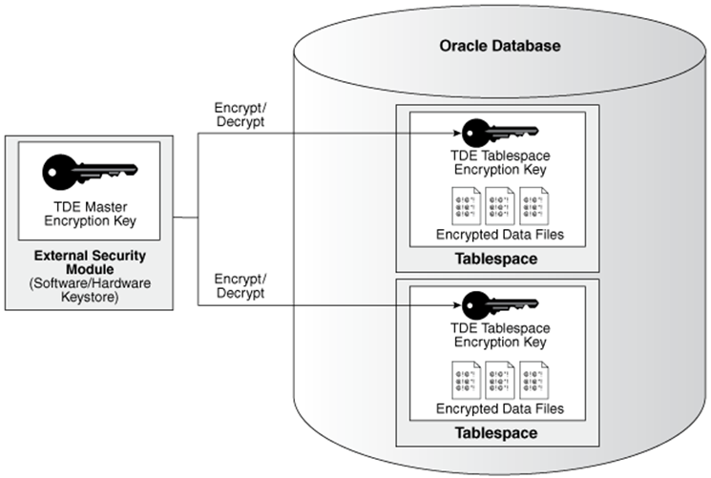
- For Oracle RAC 26ai security document, these are the essential points:
- Data Encryption at Rest: Protects sensitive database information stored in data files.
- Column-Level Encryption: Encrypts selected sensitive database columns.
- Tablespace-Level Encryption: Encrypts entire tablespaces.
- Encryption Algorithms: Supports AES encryption, including AES-256.
- Key Management: Uses TDE wallets or external keystores to manage master encryption keys.
- Oracle Key Vault Integration: Supports centralized key management.
- Oracle RAC Support: Supports encrypted databases across RAC instances.
- Transparent Operation: Automatically decrypts data for authorized database users and applications.
- Backup Protection: Supports encryption of database backups.
- Administration & Monitoring: Includes keystore configuration, key rotation, encryption-status checks and technical validation.

Fore detailed documentation please refer to below link.

https://docs.oracle.com/en/database/oracle/oracle-database/26/dbtde/introduction-to-transparent-data-encryption.html

- Encryption protocols

Oracle TDE supports the following protocols:

- Encryption at Rest: AES-128, AES-192, AES-256, ARIA-128/192/256, and legacy 3DES168.
- Encryption in Transit: Oracle Database supports TLS 1.2 and TLS 1.3.
- Encryption Key Management: TDE keystores with optional Oracle Key Vault integration.

High Availability / Backup / Disaster Recovery
- HA architecture
- Redundancy design
- DR architecture diagram
- Backup architecture
- Replication design
- Backup encryption
- DR-site connectivity
- RTO/RPO commitment
- Failover approach
- HA/DR testing approach
These are specifically listed as required evaluation documents.
- HA architecture

Oracle Exadata and Oracle Real Application Clusters (RAC) provide high availability through redundant infrastructure, active-active database clustering, automated failover, and workload distribution.
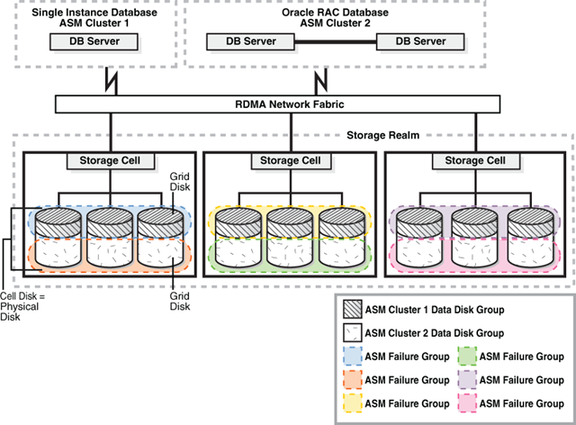

- HA Features

- Active-Active RAC Clustering: Multiple database instances operate simultaneously against a shared database.
- Automatic Failover: Database services relocate to surviving RAC instances following supported instance or node failures.
- Oracle Clusterware: Monitors and manages cluster resources, database instances, services, and failover operations.
- SCAN & VIP: Provide consistent database connectivity and support connection redirection.
- Oracle ASM: Manages shared database storage and provides configured storage redundancy.
- Exadata Infrastructure Redundancy: Provides redundant database servers, storage servers, network paths, and power components.
- Load Balancing: Distributes database workloads across available RAC instances through database services and supported connection pools.
- Application Continuity: Supports transaction replay and improved application failover when properly configured with compatible clients.
- Rolling Maintenance: Supports reduced-downtime maintenance operations, subject to the applicable patching procedure.

- Redundancy design

Oracle Exadata provides redundancy across hardware, storage and networking, while Oracle RAC provides database-instance redundancy and service availability.

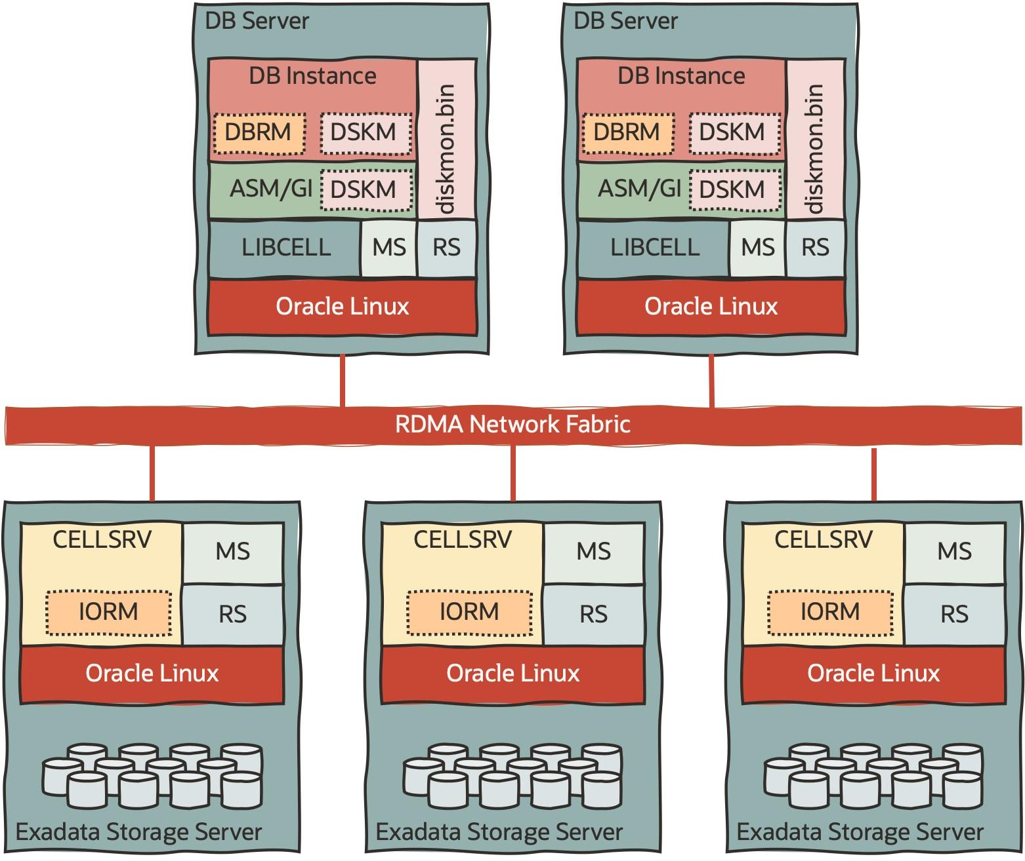

- Redundant Database Servers
- Redundant Storage Servers
- Redundant RDMA Fabric Switches
- Redundant PDUs
- Automatic Storage Management
- Oracle Real Application Clusters
- Application Continuity

Fore detailed documentation please refer to below link.

https://www.oracle.com/a/tech/docs/exadata-operational-best-practices.pdf
- DR architecture diagram

Oracle Exadata provides a highly available and resilient database infrastructure through Oracle Real Application Clusters (RAC) and Oracle Data Guard. RAC enables multiple database nodes to operate as a single database, while Data Guard maintains a synchronized standby database at the Disaster Recovery (DR) site. Oracle Data Guard Broker supports controlled switchover and failover operations, ensuring business continuity and minimizing downtime

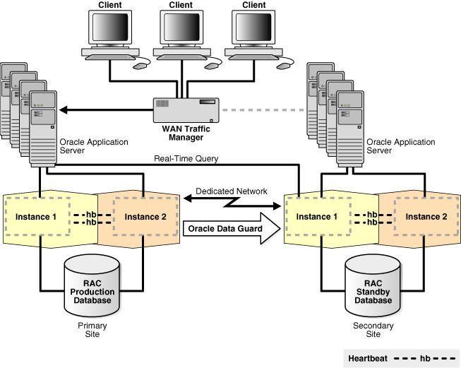

- Backup architecture

Oracle Recovery Manager (RMAN) provides database backup and recovery capabilities using disk-based backup channels. The Fast Recovery Area (FRA) stores recovery-related files, including RMAN backups and archived redo logs. Oracle Database and RMAN automatically manage files within the FRA. RMAN maintains backup metadata in the database control file and supports backup retention policies. The FRA simplifies backup administration and recovery-file management.

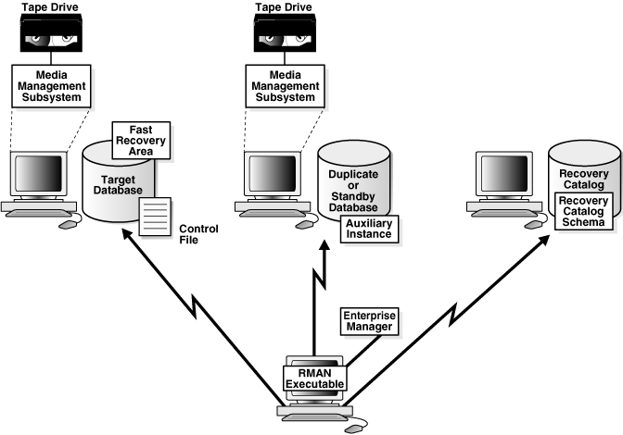
- Replication design

Oracle Data Guard maintains a transactionally consistent copy of the primary database at the standby site. It automatically maintains the standby database by transmitting redo data from the primary database and applying it to the standby database.

- Redo Transport Services: Control the automated transfer of redo data from the production database to one or more archival destinations.
- Apply Services: Apply redo data on the standby database to maintain consistency with the primary database.
- Physical Standby Database: Maintains a block-for-block copy of the primary database using Redo Apply.
- Role Transitions: Support switchover and failover operations to change database roles for planned maintenance or disaster recovery.

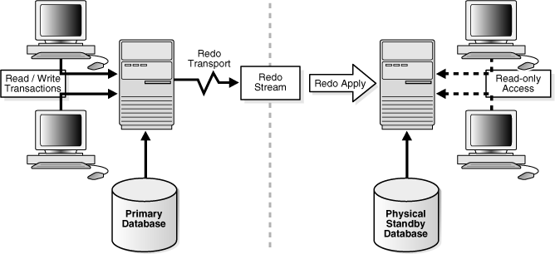

- Backup encryption

The proposed on-premises Oracle Exadata X11M solution utilizes Oracle Recovery Manager (RMAN) with Transparent Data Encryption (TDE) and encrypted backup sets to ensure secure database backup and recovery.

Supported Backup Operations:

- Full Database Backup: Complete database backup, including TDE-encrypted datafiles.
- Incremental Backups: Level 0 and Level 1 backups for efficient data protection.
- Archived Redo Log Backup: Supports point-in-time recovery.
- Tablespace Backup: Backup and recovery of individual tablespaces.
- Control File & SPFILE Backup: Protects database configuration and metadata.
- AES-256 Encrypted Backups: Supports secure RMAN backup encryption.
- TDE Keystore Backup: Protects encryption keys required for database recovery.

Oracle RMAN supports encrypted disk backups through the Oracle Advanced Security option. Secure keystore management, backup validation, and periodic recovery testing help ensure data protection and recoverability.

- RTO/RPO commitment

The on-premises Oracle Exadata solution is aligned with Oracle Maximum Availability Architecture (MAA) Gold, designed for business-critical applications. The architecture incorporates Oracle Real Application Clusters (RAC), database replication using Oracle Active Data Guard, and automatic failover.

- As per Oracle MAA Gold reference architecture, the following recovery objectives are defined:

Parameter | Recovery Objective
Local High Availability RTO | Less than 60 seconds
Regional Disaster Recovery RTO | Less than 5 minutes
Recovery Point Objective (RPO) | Zero or near-zero

- These objectives are based on Oracle MAA Gold architecture and require appropriate implementation, configuration, and validation.
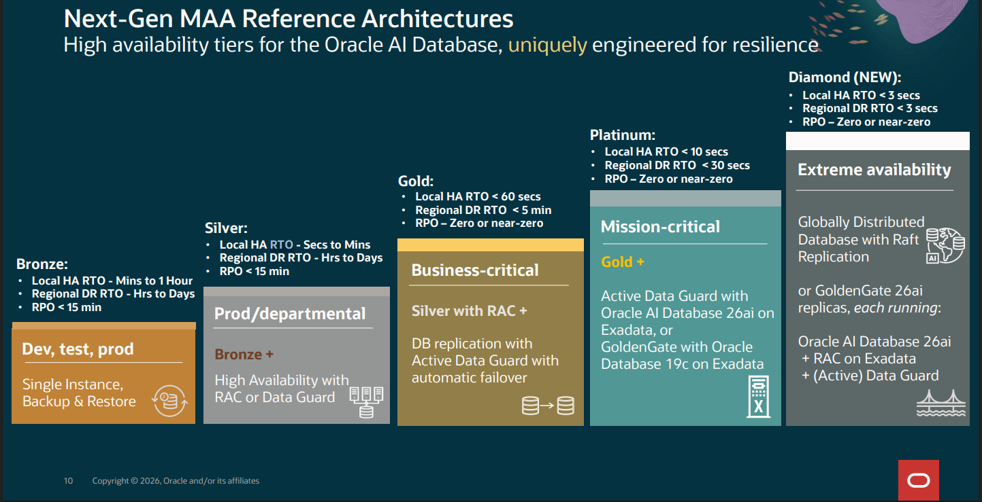
- Failover approach

The on-premises Oracle Exadata failover architecture utilizes Oracle Real Application Clusters (RAC) for local database high availability and Oracle Data Guard for disaster recovery between the Primary and DR data centers.

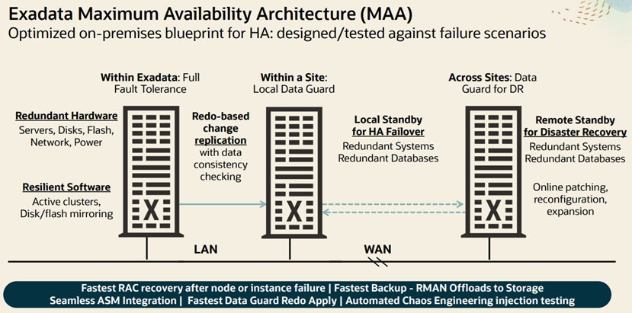

- RAC Instance Failover: Oracle RAC maintains database availability during individual node or instance failures.
- Data Guard Failover: Enables transition of the standby database to the primary role when the primary database becomes unavailable.
- Fast-Start Failover (FSFO): Supports automatic failover to the standby database when configured failover conditions are satisfied.
- Planned Switchover: Enables controlled database role transitions for planned maintenance.
- Application Reconnection: Database services and application connection configurations support reconnection to the available database node.

For RPO/RTO statistics, please refer to Oracle official documentation available at the link below

https://www.oracle.com/a/tech/docs/maa-onpremises-overview.pdf

- HA/DR testing approach

The on-premises Oracle Exadata solution follows Oracle Maximum Availability Architecture (MAA) best practices for validating high availability and disaster recovery capabilities.

- RAC Node Failure Testing: Validate database availability and application connectivity during individual RAC node or instance failures.
- Data Guard Switchover Testing: Perform planned switchovers between primary and standby databases to validate role transitions.
- Replication Validation: Verify redo transport, redo apply, and standby database synchronization.
- Backup and Recovery Testing: Validate RMAN backup, restore, and database recovery operations.
- Application Connectivity Testing: Verify application reconnection and database service availability following failover.
- DR Readiness Testing: Conduct periodic HA/DR exercises and document test results, recovery procedures, and corrective actions.

Hardware Proposal
Detailed BOQ
- Compute nodes
- Storage appliances
- Networking
- Racks/PDU/cooling where applicable
- Spares/buffer stock
- Other hardware components

Oracle Hardware and Software BOQ
The table below provides the detailed Bill of Quantities (BOQ) for the Oracle Exadata solution, including hardware, software licenses and associated support services for both the Production (PR) and Disaster Recovery (DR) sites.

- Oracle Exadata High Capacity (HC) Solution-PR Site.
- Exadata Hardware Support PR Site
- Exadata Storage Server Software PR Site
- Exadata Software Support PR Site
- Oracle Exadata High Capacity (HC) Solution-DR Site.
- Exadata Hardware Support DR Site
- Exadata Storage Server Software DR Site
- Exadata Software Support DR Site
- Software Licenses
- Software Support

Sr. | Description | Qty
 | TOTAL
1.00 | Oracle Exadata High Capacity (HC) Solution-PR Site.
1.00 | Exadata Database Machine X11M: model family
1.01 | Exadata Database Machine X11M Rack: two 3 TB memory database servers plus Chassis (for factory installation) | 1
1.02 | Exadata Storage Server X11M High Capacity (HC) with total 1.5 TB memory (XRMEM and system memory) plus Network Fabric (for | 3
1.03 | One Cisco 9336C RoCE networking fabric switch v2 (for factory installation) | 2
1.04 | QSFP28 passive copper cable: 3 meters, 30 AWG | 10
1.05 | QSFP28 passive copper cable: 1 meter, 30 AWG | 8
1.06 | One Cisco 9348 management switch v2 (for factory installation) | 1
1.07 | Exadata Database Machine: expansion switch kit for Network Fabric v2 (for factory installation) | 1
1.08 | Two 3-phase high voltage 24 kVA PDUs with IP44 30 A plugs for EMEA and APAC except Japan and Taiwan (for factory installation) | 1
1.09 | Engineered Systems 1 RU filler panel v2 | 28
1.10 | Exadata Database Machine X11M: Oracle Linux software image for database server (for factory installation) | 1
1.11 | Exadata Database Machine X11M: Oracle Linux software image for storage server (for factory installation) | 1
1.12 | Oracle Dual Port 25 Gb Ethernet Adapter v2 | 2
1.13 | Optical cable: 80 feet, LC-LC, 50/125 diameter, OM4, LSZH, riser | 12
1.14 | Oracle 10/25 GbE Dual Rate SFP28 Short Range (SR) Transceiver | 12
1.15 | Oracle Advanced Support Gateway Server E6-2L (for field installation) | 1
1.16 | Single Jumper cable: 2 meters, C13 plug | 2
1.17 | Freight Fee | 1
2.00 | Exadata Hardware Support PR Site
2.01 | Hardware Support for Year 1 | 1
2.02 | Hardware Support for Year 2 | 1
2.03 | Hardware Support for Year 3 | 1
2.04 | Hardware Support for Year 4 | 1
2.05 | Hardware Support for Year 5 | 1
3.00 | Exadata Storage Server Software PR Site
3.01 | Exadata Storage Server Software - Disk Drive Perpetual | 36
4.00 | Exadata Software Support PR Site
4.01 | Software Support for Year 1 | 1
4.02 | Software Support for Year 2 | 1
4.03 | Software Support for Year 3 | 1
4.04 | Software Support for Year 4 | 1
4.05 | Software Support for Year 5 | 1
5.00 | Oracle Exadata High Capacity (HC) Solution-DR Site.
5.00 | Exadata Database Machine X11M: model family
5.01 | Exadata Database Machine X11M Rack: two 1.5 TB memory database servers plus Chassis (for factory installation) | 1
5.02 | Exadata Storage Server X11M High Capacity (HC) with total 1.5 TB memory (XRMEM and system memory) plus Network Fabric (for | 3
5.03 | One Cisco 9336C RoCE networking fabric switch v2 (for factory installation) | 2
5.04 | QSFP28 passive copper cable: 3 meters, 30 AWG | 10
5.05 | QSFP28 passive copper cable: 1 meter, 30 AWG | 8
5.06 | One Cisco 9348 management switch v2 (for factory installation) | 1
5.07 | Exadata Database Machine: expansion switch kit for Network Fabric v2 (for factory installation) | 1
5.08 | Two 3-phase high voltage 24 kVA PDUs with IP44 30 A plugs for EMEA and APAC except Japan and Taiwan (for factory installation) | 1
5.09 | Engineered Systems 1 RU filler panel v2 | 28
5.10 | Exadata Database Machine X11M: Oracle Linux software image for database server (for factory installation) | 1
5.11 | Exadata Database Machine X11M: Oracle Linux software image for storage server (for factory installation) | 1
5.12 | Oracle Dual Port 25 Gb Ethernet Adapter v2 | 2
5.13 | Optical cable: 80 feet, LC-LC, 50/125 diameter, OM4, LSZH, riser | 12
5.14 | Oracle 10/25 GbE Dual Rate SFP28 Short Range (SR) Transceiver | 12
5.15 | Freight | 1
6.00 | Exadata Hardware Support DR Site
6.01 | Hardware Support for Year 1 | 1
6.02 | Hardware Support for Year 2 | 1
6.03 | Hardware Support for Year 3 | 1
6.04 | Hardware Support for Year 4 | 1
6.05 | Hardware Support for Year 5 | 1
7.00 | Exadata Storage Server Software
7.01 | Exadata Storage Server Software - Disk Drive Perpetual | 36
8.00 | Exadata Software Support DR Site
8.01 | Software Support for Year 1 | 1
8.02 | Software Support for Year 2 | 1
8.03 | Software Support for Year 3 | 1
8.04 | Software Support for Year 4 | 1
8.05 | Software Support for Year 5 | 1
9.00 | Software Licenses
9.00 | Software
9.01 | Oracle Database Enterprise Edition - Processor Perpetual | 24
9.02 | Oracle Real Application Clusters - Processor Perpetual | 24
9.03 | Oracle Diagnostics Pack - Processor Perpetual | 24
9.04 | Oracle Tuning Pack - Processor Perpetual | 24
9.05 | Oracle Partitioning - Processor Perpetual | 24
9.06 | Oracle Database Vault - Processor Perpetual | 24
9.07 | Oracle Advanced Security - Processor Perpetual | 24
9.08 | Oracle Key Vault - Server Perpetual | 2
9.09 | Oracle Data Integrator Enterprise Edition - Processor Perpetual | 5
9.10 | Oracle GoldenGate - Processor Perpetual | 36
9.11 | Oracle Analytics Server or Oracle Business Intelligence Suite Extended Edition - Processor Perpetual | 6
10.00 | Software Support
10.01 | Software Support for Year 1 | 1
10.02 | Software Support for Year 2 | 1
10.03 | Software Support for Year 3 | 1
10.04 | Software Support for Year 4 | 1
10.05 | Software Support for Year 5 | 1

Technical Datasheets of components
Please refer to the following official Oracle technical datasheets for the proposed components:

Oracle Exadata X11M:
https://www.oracle.com/a/ocom/docs/engineered-systems/exadata/exadata-x11m-ds.pdf

Oracle Data Integrator:
https://www.oracle.com/asean/a/tech/docs/odi-ee-ds.pdf

Oracle Analytic Server:
https://www.oracle.com/technetwork/middleware/bi-publisher/overview/bipublisherdatasheet-129370.pdf

Oracle Advanced Security:
https://www.oracle.com/middleeast/a/tech/docs/dbsec/aso/advanced-security-ds.pdf

Oracle GoldenGate:
https://www.oracle.com/in/a/ocom/docs/oracle-goldengate-datasheet.pdf

Oracle Key vault:
https://www.oracle.com/a/tech/docs/dbsec/ds-security-key-vault.pdf

Delivery & Commissioning Plan
- Binding hardware delivery schedule
- Installation schedule
- Commissioning schedule
- Project implementation schedule
- OEM supply-chain confirmation
- Procurement lead-time information
- Delivery-risk assessment
- Contingency plan
- Installation methodology
- Rack-and-stack methodology
- Testing/acceptance approach
- Installation schedule

The project activities will be carefully planned and where feasible executed in parallel to optimize the overall project timeline. Execution will be aligned with the readiness of the respective hardware and environments, activity dependencies, resource availability, Oracle-recommended best practices, and the client’s review and approval process. The implementation sequence and schedule will remain flexible, allowing necessary adjustments in mutual coordination with the client to ensure a smooth, controlled, and successful delivery.

S# | Phase | Activities description | Estimated time
1 | Production Site | Exadata X11M, OEM, Platinum Gateway, ASR, middleware and security products deployment | 15-20 weeks
2 | DR Site | Exadata configuration, DR integration, replication and security setup | 10-15 weeks
3 | Development setup | Core DW Development DB, Middleware setup and data masking | 5-8  weeks
4 | Testing & Validation | HA / DR failover, recovery, integration and security validation | 2-3  weeks
5 | Knowledge Transfer | Knowledge transfer, documentation, and final handover to technical team | 1-2  weeks

High Level Activities of Production / PR Site:

- Installation and configuration of Oracle Exadata X11M.
- Installation and configuration of Oracle Platinum Gateway and ASR.
- Installation and configuration of Oracle Enterprise Manager.
- Installation and configuration of Oracle Key Vault.
- Configuration of TDE, Database Vault, and Unified Auditing.
- Installation and configuration of Oracle ODI, OGG and OAS.
- High availability testing and production readiness validation.

High Level Activities of Disaster Recovery / DR:

- Installation and configuration of Oracle Exadata X11M.
- Integration with OEM monitoring.
- Configuration of OKV for the approved DR architecture.
- Validation of database security controls.
- DR failover and recovery testing.

High Level Activities of Development Environment:

- Installation and configuration of Oracle Database on Non-Exadata environment.
- Installation and configuration of Oracle ODI, OGG, and OAS.
- Installation and configuration of Oracle OGG
- Installation and configuration of Oracle OAS.
- Validation of connectivity, integration, and development readiness.

- Commissioning schedule

- Exadata Configuration as per (OEDA) Configuration
- Database nodes setup
- Storage nodes setup
- Oracle Cluster installation and Configuration
- Oracle Databases Installation and Configuration
- Oracle Cluster Infrastructure HA Services testing
- Oracle Database testing
- Oracle Exadata Hardware redundancy testing
- Oracle Exadata handover

- Installation methodology

- Pre-installation and Site Planning
- Meeting with customer to finalize Configuration of Exadata
- Site visit to check Exadata requirements
- Oracle Exadata Delivery
- Oracle Exadata Rack and stack
- Oracle Exadata Cabling
- Oracle Exadata Automated Installation rollout
- Oracle Exadata Configuration Validation
- Oracle Exadata Handover

- Rack-and-stack methodology

- Oracle Exadata Inspect and Unpack
- Oracle Exadata Power up
- Oracle Exadata Initial Hardware Health Checks
- Oracle Exadata Cabling

- Testing/acceptance approach

- Oracle Exadata Compute Nodes Network Redundancy test
- Oracle Exadata Storage Patch Redundancy test
- Oracle Exadata Compute and Storage Nodes power Redundancy Test
- Oracle Rac Cluster Functionality test
- Oracle Database Functionality test

Disclaimer: Any delay or lack of timely engagement from the Client side, including delays in providing access, information, approvals, resources, or required support, may extend the project timeline.

Any additional effort, resources or time required beyond the agreed project duration will be charged separately.

Implementation Methodology
- Project implementation methodology
- Project plan
- Work breakdown structure
- Implementation milestones
- Resource plan
- Project governance
- Installation plan
- Configuration plan
- Commissioning plan
- Infrastructure acceptance plan
- Handover plan
- Knowledge-transfer plan
- Risk-management plan
- Dependency management
- Coordination with the separate Data Platform Implementation Vendor
- Resource plan

S# | Environment | Location | Exadata Resources | DB & Middleware | Access type
1 | Production | Islamabad | 3 | 3 | Local / Onsite
2 | DR | Lahore | 3 | 3 | Local / Onsite
3 | Development | Islamabad | 2 | 2 | Local / Onsite

- Installation plan

1. Oracle Exadata X11M – Production and Disaster Recovery:

- Installation, configuration, and readiness validation of Oracle Exadata X11M at Production and DR sites.
- Database platform configuration and environment validation.
- High Availability (HA) and Disaster Recovery (DR) failover testing across applicable hardware and database scenarios.

2. Support Infrastructure, Monitoring and Alerting:

- Installation and configuration of the Oracle Platinum Gateway server.
- ASR configuration and validation for supported infrastructure components.
- Installation and configuration of Oracle Enterprise Manager (OEM).
- Exadata discovery, monitoring, and alert configuration.

3. Oracle Middleware Products – Installation and Deployment:

- Oracle Data Integrator (ODI): Installation, configuration, and basic integration setup.
- Oracle GoldenGate (OGG): Installation, configuration, and source/target database discovery.
- Oracle Analytics Server (OAS): Installation and configuration.
- Validation of deployed middleware components and their connectivity with the Exadata DB.

4. Oracle Database Security – Configuration and Validation:

- Oracle Advanced Security (TDE): Configure Transparent Data Encryption and validate database encryption functionality.
- Oracle Unified Auditing: Configure audit policies and validate audit event generation and retrieval.
- Oracle Key Vault (OKV): Installation, configuration, and database endpoint registration.
- Validate security configurations and integration with the Exadata environments.

5. Development Environment Preparation:

- Prepare and configure the required development infrastructure.
- Install and configure the applicable Oracle database and middleware components.
- Validate environment readiness and connectivity for development and testing activities.

6. High Availability and Disaster Recovery Testing:

- Conduct planned failover and recovery tests for applicable infrastructure and database components.
- Validate database availability, service continuity, and recovery procedures.
- Document test scenarios, results, and identified gaps.

7. Knowledge Transfer and Technical Documentation:

- Conduct knowledge transfer and technical enablement sessions for the client's IT team.
- Deliver implementation, configuration, deployment, and operational documentation.
- Provide HA/DR test results and relevant configuration records.

8. Scope Coverage:

- Production (PR)
- Disaster Recovery (DR) and
- Development environments as applicable to each component and the agreed project scope.

9. Oracle Exadata Installation HL steps:

Conduct Staging Area Inspection: Unbox the Exadata cabinet outside the clean room to prevent shipping dust from entering the server aisles.

Execute Physical Placement: Roll the rack to its designated floor tiles, lower the leveling feet, and secure the seismic stabilizing brackets.

Establish Power Connectivity: Plug in the redundant power cables to separate PDU paths, verifying that the physical status lights boot into standby mode.

Route Physical Uplinks: Run structural fibers from the database compute nodes out to the client core switches, and route the Ethernet lines to the management switch patch panel.

Stage the OEDA File: Upload the pre-validated Oracle Exadata Deployment Assistant (OEDA) XML/ZIP configuration bundle directly onto the master database node via a local crash cart or service terminal.

Execute Automated Provisioning Script: Run the OneCommand automation utility to format the storage cells, initialize the CELLSRV software layer, and deploy the foundational Oracle Linux operating systems.

Deploy Grid Infrastructure: Run the Clusterware engine setup via the automation framework to create automated storage management (ASM) partitions.

Initialize Database Home: Automatically compile the final Oracle Database system binaries and provision the initial multi-tenant containers.

Disclaimer: Any delay or lack of timely engagement from the Client side, including delays in providing access, information, approvals, resources, or required support, may extend the project timeline. Any additional effort, resources, or time required beyond the agreed project duration will be charged separately.

- Configuration plan

- Oracle Exadata Unpacking
- Pre-installation and Site Planning
- Meeting with customer to finalize Configuration of Exadata
- Site visit to check Exadata requirements
- Oracle Exadata Inspect and Unpack
- Oracle Exadata Power up
- Oracle Exadata Initial Hardware Health Checks
- Oracle Exadata Cabling
- Exadata Configuration as per (OEDA) Configuration
- Host names Configuration
- Network Configuration (Administration Network, Private Network, Client Network)
- Disk Groups Configuration to configure RAW disks into Functional usable Disks.
- Initialize Grid Infrastructure and databases
- Database nodes setup
- Storage nodes setup
- Oracle Cluster installation and Configuration
- Oracle Databases Installation and Configuration
- Oracle Cluster Infrastructure HA Services testing
- Oracle Database testing
- Oracle Exadata Hardware redundancy testing
- Oracle Exadata handover

- Commissioning Plan

- Clusterware, CSS, and CRS must report fully operational on all database nodes.
- All intelligent storage servers must show an "Online" status with no hardware alerts.
- All local and SCAN (Single Client Access Name) listeners must actively listen for incoming routes.
- Execute Automated Architecture Audit
- Conduct Inter-Node Network Validation
- Execute Synthetic I/O Burn-In Testing
- Configure I/O Resource Management (IORM)
- Conduct High Availability Failover Drills
- Compile Commissioning Documentation

- Infrastructure Acceptance Plan

Test Case | Detailed Scenario Description | Expected Acceptance Criteria
Network Throughput & Latency | Run an internal data transmission test across the private 100 Gbps RoCE network fabric using maximum packet configurations (Jumbo Frames, MTU 9000). | The network must show zero dropped packets and maintain sub-millisecond latencies between compute nodes and storage cells.
SCAN / VIP Resolution | Simulate client connections targeting the Single Client Access Name (SCAN) and Virtual IPs (VIPs) from external corporate subnets | The network switches must load-balance the connection incoming requests equally across all database compute nodes.
Smart Scan & I/O Validation | Run synthetic multi-threaded query loads using the OrION framework to push full-table reads to the storage cells. | The system must demonstrate active offloading; CPU consumption remains on the storage cells while compute nodes stay clear.
Redundant Power Failover | Physically disconnect one of the main power cables from a primary facility PDU while the database cluster is running a simulated query load. | The redundant secondary power supply instantly assumes the load; the cluster experiences zero dropped sessions or node crashes.
Compute Node Eviction | Force a hard reboot on a running database compute node (simulating a sudden motherboard failure) while a heavy data pipeline is processing. | The remaining nodes in the Oracle RAC cluster must take over the workload within seconds without dropping the core database instance

- Handover plan

- Conduct the Handover Alignment Meeting
- Review the Technical Documentation
- Perform Live Credential Validation on every component of Oracle Exadata
- Ask End User to change the passwords of all components of Oracle Exadata
- Sign the Transfer of Ownership Agreement

- Knowledge-transfer plan

- Core Theoretical Architecture Reviews
- Conduct Real-World Failure Simulation Drills
- Basic Administration of Cellcli and Dcli Commands
- Administration of I-LOMs
- Basit Network Administration (monitoring the Status of Network ports and Bond)
- Oracle Real Application Cluster customize Knowledge transfer session
- Oracle Data Guard Knowledge transfer session

Performance & Benchmarking
- Compute-performance benchmarks
- Storage-performance benchmarks
- Network throughput/latency benchmarks
- MPP performance benchmarks
- Streaming throughput/latency
- HTAP performance evidence
- Comparable enterprise deployment benchmarks
- Scalability evidence
- Compute-performance benchmarks

The CPU scalability within each database server enables superior performance and utilization efficiency by enabling greater database and VM consolidation, higher OLTP transaction throughput, and significantly more parallelized analytic workloads to coexist and consume fewer data center resources.

Fore detailed documentation please refer to below link

https://www.oracle.com/a/ocom/docs/engineered-systems/exadata/exadata-x11m-ds.pdf

- Storage-performance benchmarks

Exadata X11M HC and EF Storage Servers include Exadata RDMA Memory (XRMEM), further enhancing performance by delivering up to 2.8 million 8K OLTP Read IOPS. Each server is populated with 1.5 TB of DDR5 memory, 1.25 TB of which is configured as Exadata RDMA Memory and used as a caching tier between the database buffer cache and Flash Cache, and the remaining 256 GB is used for Exadata System Software. SQL Scan throughput from flash is 2.2X faster than the prior generation, reaching 100 GB/s per storage server. In addition, Smart Scan also reads columnar data in XRMEM accelerating
analytics query throughput up to 500 GB/s. Two 32-core x86 processors are included for Exadata System Software operations in each HC and EF storage server.

Fore detailed documentation please refer to below link

https://www.oracle.com/a/ocom/docs/engineered-systems/exadata/exadata-x11m-ds.pdf

- MPP performance benchmarks

Maximum SQL XRMEM Read IOPS for Quarter Rack are 5,600,000 and Maximum SQL Flash Write IOPS are 3,000,000

Fore detailed documentation please refer to below link

https://www.oracle.com/a/ocom/docs/engineered-systems/exadata/exadata-x11m-ds.pdf

- HTAP performance evidence

Real-world database workloads running on Exadata X11M, utilizing the shared XRMEM Data Accelerator, can achieve up to 25.2 million OLTP Read IOPS (8K IOs)2 in a single rack.
Exadata Exascale is the world's only intelligent data architecture for the cloud. Exascale is a revolutionary leap that combines the best of Exadata and the best of the cloud. This next-generation, hyper-elastic, multi-tenant software architecture is designed to handle mission-critical OLTP, analytics, AI, JSON, and mixed Oracle Database workloads.

Fore detailed documentation please refer to below link

https://www.oracle.com/a/ocom/docs/engineered-systems/exadata/exadata-x11m-ds.pdf

- Comparable enterprise deployment benchmarks

In Following link information about Oracle Enterprise Database performance on Exadata and non-Exadata infrastructure.

Fore detailed documentation please refer to below link

https://www.oracle.com/a/ocom/docs/engineered-systems/exadata/dsc-on-x8m-openworld.pdf

- Scalability evidence

Exadata uses a scale-out architecture for both database and storage servers. As workloads grow, database, storage, and networking resources can be added to an Exadata deployment to scale without bottlenecks. The architecture scales from small to extremely large configurations to accommodate workloads of any size.

Fore detailed documentation please refer to below link

https://www.oracle.com/apac/a/ocom/docs/engineered-systems/exadata/exadata-x11m-ser-ds.pdf

Environment Architecture
- Production environment
- Development environment
- Test environment
- Environment isolation
- Network segmentation
- Security controls
- Environment parity
- Data masking
- Synthetic-data approach
- Production-to-lower-environment data movement
- Production environment

S# | Domain | Configuration Name | Servers
1 | Core Database | Oracle Exadata X11M Quarter Rack | 2-Node RAC
2 | ELT Processing | Oracle Data Integrator - ODI | 2-Node
3 | Replication | Oracle Golden Gate - OGG | 2-Node
4 | Reporting | Oracle Analytics Server - OAS | 2-Node
5 | Security | Oracle Key Vault – OKV Server | 2 Server
6 | Monitoring | Oracle Enterprise Manager - OEM | 1 Server

- Development environment

S# | Domain | Configuration Name | Servers
1 | Database | Commodity H/W | 1 Server
2 | ELT Processing | Oracle Data Integrator - ODI | 1 Server
3 | Replication | Oracle Golden Gate - OGG | 1 Server
4 | Reporting | Oracle Analytics Server - OAS | 1 Server

- Security controls

Oracle Advanced Security - Transparent Data Encryption (TDE): Encrypts database data at rest to protect sensitive information against unauthorized access to database files and backups.

Oracle Key Vault (OKV): Centrally manages encryption keys and TDE wallets, supporting secure key storage, lifecycle management and controlled access.

Oracle Unified Auditing: Captures and records database activities, privileged operations, and security-related events to support monitoring, investigations and compliance.

Oracle Database Vault: Enforces separation of duties and restricts privileged-user access to sensitive data and database operations, helping prevent unauthorized access.

- Data masking

Develop data masking policies and reusable scripts to mask sensitive information when refreshing or provisioning non-production environments from Production, ensuring data privacy and regulatory compliance.

Warranty & Support Proposal
- 24/7 support model
- Hardware warranty
- Software support
- Infrastructure support
- OEM support
- SLA commitments
- Response times
- Resolution times
- Escalation matrix
- Support organization
- Local support team
- Five-year support approach
- Post-warranty support options
- 24/7 support model

Access to My Oracle Support (24 x 7 web-based customer support system)
Oracle Provide 24 x 7 based Support for Hardware and Exadata Software.

Fore detailed documentation please refer to below link
https://www.oracle.com/contracts/docs/hardware-systems-support-policies-069182.pdf

- Hardware Warranty

Oracle may use subcontractors in the performance of technical support and it warrants the quality of subcontractor work per the warranty terms of support agreement with Oracle.

Fore detailed documentation please refer to below link
https://www.oracle.com/uk/contracts/docs/oracle_hardware_warranty_069192.pdf

- Software Support

Oracle Premier Support for Systems consists of services in support of hardware systems, operating system software and integrated software

Fore detailed documentation please refer to below link
https://www.oracle.com/contracts/docs/hardware-systems-support-policies-069182.pdf

- Infrastructure support

Hardware and Systems Support Policies apply to technical support for all Oracle server, storage, networking, and point of service product lines.

Fore detailed documentation please refer to below link
https://www.oracle.com/contracts/docs/hardware-systems-support-policies-069182.pdf

- OEM support

Oracle Premier Support for Systems consists of services in support of hardware systems, operating system software and integrated software

Fore detailed documentation please refer to below links
https://www.oracle.com/contracts/docs/057419.pdf
https://www.oracle.com/contracts/docs/hardware-systems-support-policies-069182.pdf

- SLA commitments and Response Time

As per Oracle Support Policies:

As per Oracle Support Policies (Software response time)

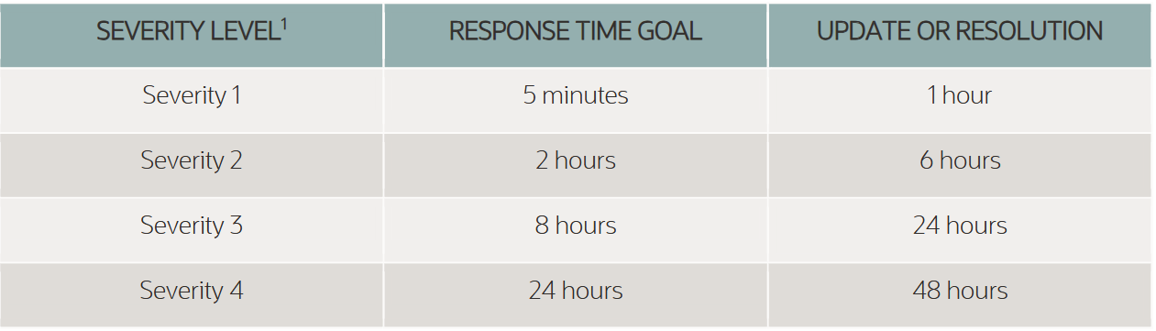

As per Oracle Support Policies (Hardware Response time)

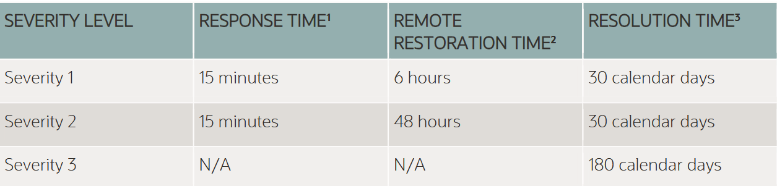

As per Oracle Support Policies (Resolution time of Hardware)

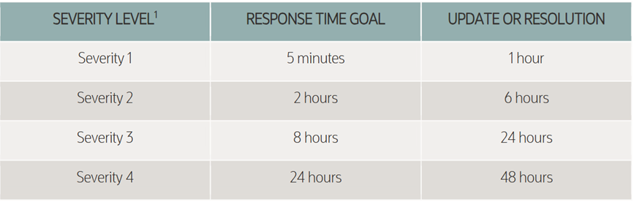

As per Oracle Support Policies (Resolution time of Software)

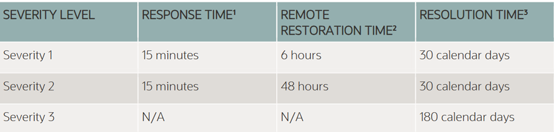

- Support organization

Premier Systems (Pvt.) Limited
Daz Tech (Pvt.) Limited
InfoMatrix (Pvt.) Ltd
Oracle Corporation

- Local support team

List of local resources from team

- Muhammad Asad Khan
- Muhammad Yasir Khan
- Asif Suleman
- Salmanullah Khan
- Bakht Ali Shah
- Ali Raza
- Sharjeel Mojib

- Five-year support approach

Annual Renewal as per Oracle Support Policies for both Hardware and software

- Post-warranty support options

- Oracle Hardware Support Through Partner
- Oracle Software Support Direct Support from Oracle

Eligibility / Qualification Evidence
This is a separate critical compliance package.

17.1. Legal / Registration Documents
At minimum, prepare:
- Company registration/incorporation documentation
- Relevant legal status documentation
- FBR NTN
- FBR GSTN
- Applicable registration/licensing evidence
- Company profile
The eligibility section identifies FBR NTN and GSTN among the required registration information.

17.2. Financial Capacity
- Audited financial statements / financial evidence for the required period
- Turnover calculation
- Chartered Accountant certification of average annual turnover
- Supporting financial documentation
- JV consolidated turnover evidence where applicable
- OEM financial-support/authorization documentation where relying on OEM standing
The minimum average annual turnover is PKR 2.0 billion for the last three fiscal years, certified by a Chartered Accountant.

17.3. Enterprise Project Experience
Provide evidence for at least:
Two enterprise-scale projects
Each project should demonstrate:
- Contract value ≥ USD 1 million or PKR equivalent
- Procurement
- Installation
- Configuration
- Commissioning
- Production/live operation
- Minimum 12 months operational period
Evidence
The evaluation specifically asks for:
- Signed contract/agreement
- Hardware delivery/commissioning certificate
- Infrastructure completion report
- Scope and scale evidence

17.4. Enterprise Software / Infrastructure Experience
Provide at least the required qualifying projects with:
- Architecture/commissioning diagrams
- Software-license procurement documentation
- Client attestations
- Evidence confirming infrastructure scale
- Evidence of commissioning
- Evidence of on-premises enterprise deployments

17.5. Continuous Operation / OEM Partnership
Provide evidence of:
- Continuous operation as registered entity
- Relevant years of operation
- Enterprise hardware/software procurement experience
- Integration experience
- Support experience
- OEM reseller/partner status
- OEM authorization certificates
- OEM partnership letters
The eligibility criteria require continuous operation and demonstrated authorization / reseller / partner status with relevant OEMs.

17.6. Local Presence
Provide appropriate evidence such as:
- HR certificate/affidavit
- Local technical staff details
- Office lease agreement
- Utility bills
- Incorporation certificate
- Evidence of operating presence in Pakistan
- Technical-resource distribution/profile
The technical evaluation expressly lists these as supporting documents.
- Technical-resource distribution/profile

Resource Name | Domain | Total  Experience | Technical Skills and Experience
Asif Suleman | Oracle  Systems | 22 years | Oracle Engineered System Exadata  Oracle Private Cloud Appliance (PCA)  Oracle Database Appliance (ODA)  Oracle Sparc system  Oracle Linux, AIX and Solaris  Oracle Sparc Servers & storage
Asad Khan | Oracle  Systems | 15 years | Oracle Engineered System Exadata  Oracle Sparc system  Oracle Linux and Solaris  Oracle Sparc Servers & storage
M. Salman ullah | Oracle  System | 9 years | Oracle Engineered System Exadata  Oracle Private Cloud Appliance (PCA)  Oracle Database Appliance (ODA)  Oracle Sparc system  Oracle Sparc Servers & storage
Muaaz Ali | Oracle  Systems | 8 years | Oracle Engineered System Exadata  Oracle Private Cloud Appliance (PCA)  Oracle IDM
Bakht Ali Shah | Oracle  Database and Middleware | 18 years | Oracle RAC Database  Oracle Data Guard  Oracle Golden Gate  Oracle Advanced Security  Oracle DB migration and Upgradation
Sharjeel Mojib | Oracle DB and Middleware | 16 years | Oracle RAC Databases  Oracle Middleware WebLogic  Oracle Golden Gate  Oracle Analytics Server
Ali Raza | Oracle DB and  Middleware | 9 years | Oracle RAC Databases  Oracle Data Guard  Oracle Middleware WebLogic  Oracle Golden Gate  Oracle Analytics Server  Oracle Enterprise Manager
Hamza Naeem | Oracle  DB and Middleware | 4 years | Oracle Databases  Oracle IDM  Oracle WebLogic Server  Oracle Data Guard

17.7. OEM Authorization / Support Evidence
For each major proposed OEM/product, prepare:
- OEM authorization letter
- OEM partnership certificate
- OEM support letter
- Enterprise support agreement
- Product authorization/reseller certificate
- Technical support commitment
- SLA/support commitment
This is especially important because the evaluation requires enterprise-support/OEM evidence for proposed components.

17.8. JV / Consortium Documents - If Applicable
If bidding as JV/Consortium/Association:
- JV/Consortium/Association agreement
- Lead-member appointment
- Power of Attorney
- Roles/responsibilities of each member
- Share of work/contract scope for each member
- Qualification evidence for each member
- Combined financial/turnover evidence
- OEM authorization/support documents applicable to each member
The tender allows a JV/Consortium of up to 3 members and requires a verifiable JV/Consortium agreement and Power of Attorney for the Lead Member.

Mandatory Technical Compliance Matrix
I strongly recommend creating a dedicated Requirement-by-Requirement Compliance Matrix containing:
Column | Content
Requirement No. | Tender/RFP reference
Requirement | Exact tender requirement
Compliance | Comply / Partially Comply / Not Comply
Proposed Solution | Vendor response
Product/Model | Proposed OEM/product
Evidence | Datasheet/document reference
Page Reference | Proposal page
Remarks | Clarification/deviation
This should cover all technical specifications in Sections 5 & 6, not merely the scored evaluation criteria.
The ITB states that the bidder must provide documentary evidence that the supplied goods conform to the technical specifications and standards.

Financial Proposal
The Financial Proposal is a separate submission.

19.1. Financial Price Format
The prescribed financial format contains:
Category 1 — Hardware Supply / CAPEX
- Compute Nodes
- Storage Appliances
- Networking Equipment
- Rack Infrastructure
- Spares/Buffer Stock
- Other Hardware Components
Category 2 — Software Licenses / CAPEX
- ELT/ETL Tool
- Object Storage/Lakehouse
- MPP Enterprise Data Warehouse
- BI/Analytics
- Data Governance & Catalog
- Operating System
- Other required licensed components
Installation, Commissioning & Testing
- Site preparation/rack-and-stack/cabling/network configuration
- OS installation/hardening/platform software installation
- HA/DR/security configuration
- Infrastructure acceptance testing/sign-off
Category 3 — Hardware Warranty & Support / OPEX
- Year 1
- Year 2
- Year 3
- Year 4
- Year 5
Category 4 — Software Maintenance & Support / OPEX
- Year 1
- Year 2
- Year 3
- Year 4
- Year 5
For every applicable line, the financial schedule requires:
- Quantity
- Unit
- Unit price excluding applicable GST/PST
- GST/PST
- Unit price including taxes
- Total cost including taxes
The prescribed financial table requires these fields and categories.

19.2. Financial Proposal Supporting Information
- Complete commercial BOQ
- Unit rates
- Taxes
- Total price
- Total price in words
- CAPEX
- OPEX
- Five-year support costs
- Warranty costs
- Software licensing costs
- Installation/commissioning costs
- Post-warranty support options
- Any other cost required for complete platform operation
The tender states that partial bidding is not permitted and all items/services in the scope/BOQ must be quoted.

Beneficial Ownership
Submit the prescribed:

Beneficial Ownership / Ultimate Beneficial Owners declaration

The EPADS submission section specifically identifies Beneficial Ownership as a vendor document required.

The form includes information such as:
- Name
- Father’s/Spouse’s Name
- Beneficial-owner information
- Ownership details
- Declaration

Bid Security
Required at submission
Pay Order in the amount specified for the applicable lot/item.
Also:
- Scan the original.
- Upload scanned copy on EPADS.
- Submit original physically before the bid deadline.
- Ensure validity meets the prescribed requirement.
- Ensure bidder's complete legal name is correctly stated.

